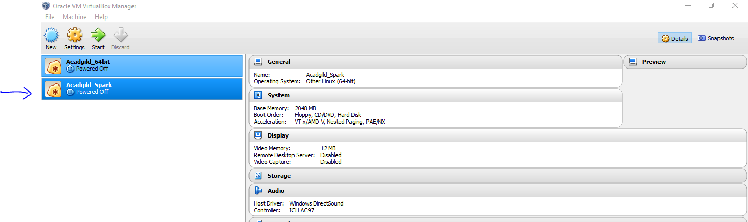

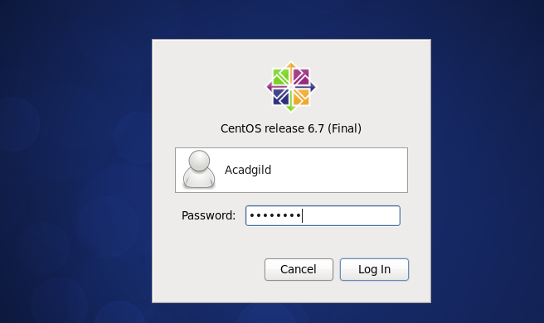

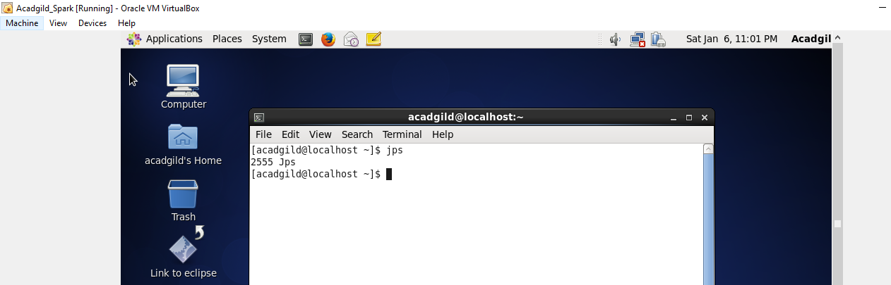

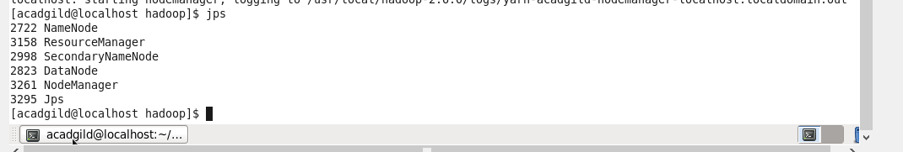

Moving into Spark

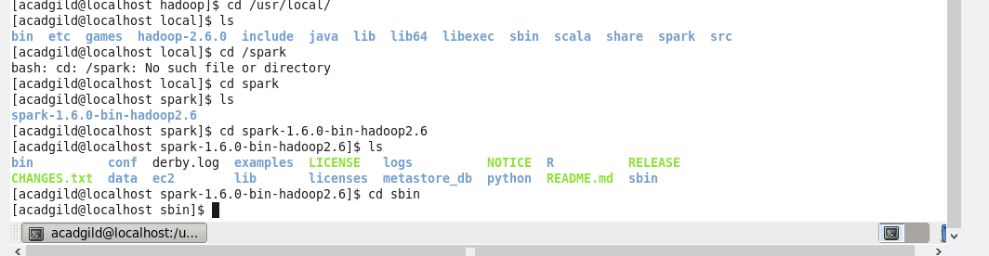

Starting Master & slave

